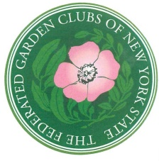
Federated Garden Clubs of NYS
Scholarship Application
DEC Environmental Education Camp
Camp Rushford - Camp Pack Forest – Camp Colby - Camp DeBruce

Camp Rushford: This camp is available and suitable for campers in the 11-to-17-year age group. More information at: https://www.dec.ny.gov/education/1879.html
Camp Pack Forest: This camp is suitable for the 11- to- 17-year age group. More information at https://www.dec.ny.gov/education/1875.html
Camp Colby: This camp is for campers in the 11-to-17-year age group.
More information at: http://www.dec.ny.gov/education/1877.html

Camp DeBruce: This camp is for campers in the 11-17-year age group.
More information at: http://www.dec.ny.gov/education/1881.html
All camps are for a one week stay and do require a refundable deposit of $50.00 when space at these camps is confirmed. This deposit will be returned to the applicant upon completion of the camping week. Parents must provide transportation to and from the camp. Campers must be the minimum age by December 1st prior to the camp year they are to attend.
_____________________________________________________________________

Camp of Choice:
Camper’s Name Phone
Parent’s Name
Camper’s Address
City Zip
Birth date Age Grade Level
Have you previously attended a DEC Camp? Date Where?
Applicant’s Signature
Parent’s Signature
If you are interested, please attach to this application a paragraph, either written or typed, explaining why you would like to attend an environmental educational camp. Spelling, punctuation, and grammar will be considered in the final decision.

Return application by November 25th to: Babbidean Urban Huber, Scholarship Chairman,
325 Roycroft Blvd., Amherst 14226 or at babbidean@hotmail.com

