FGCNYS
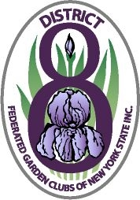
Eighth District
Scholarship Application
DEC Environmental Education Camp
Camp Rushford - Camp Pack Forest

Camp Rushford is located near Rushford Lake in the 4500 acre Hanging Bog Wildlife Management Area. It has unlimited space for outdoor learning and recreation. This camp is available and suitable for campers in the 11- to- 13- year age group. For info: www.dec.ny.gov/education/1879.html
Camp Pack Forest is located on a small lake in the Adirondack Park with access to the Hudson River. It also offers unlimited space for outdoor learning and recreation and will surely heighten the camper’s awareness of the environment. For info: www.dec.ny.gov/education/1875.html
Both camps are for a one week stay and do require a refundable deposit of $50.00 when space at these camps is confirmed. This deposit will be returned to the applicant upon completion of the camping week.

Campers must be the minimum age by December 1st of the year prior to the year they are planning to attend camp.

Parents are responsible for transportation to and from the camps.
_____________________________________________________________________

Camp of Choice:
Camper’s Name Phone
Parent’s Name
Camper’s Address
City Zip
Birth date Age Grade Level
Have you previously attended a DEC Camp? Date Where?
Applicant’s Signature
Parent’s Signature
- Camper to include a brief essay on his interest and reasons for wishing to attend this camp and include any list of activities or experiences that might qualify him/her to receive this scholarship. Spelling, punctuation, and grammar will be considered in the final decision.

Return application by November 25th to: Babbidean Urban Huber, 325 Roycroft Rd., Amherst, NY 14226 or at babbidean@hotmail.com

